How to Create UEFI SCCM Bootable USB

- 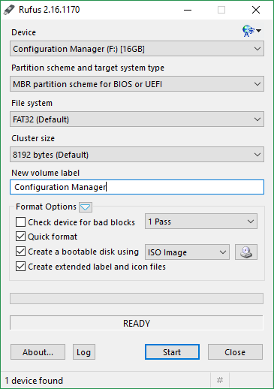
- Click the CD icon highlighted above
- Select the SCCM .ISO file downloaded earlier.
- Change the Partition Scheme to MBR partition scheme for UEFI
- Click Start, once complete close Rufus.

